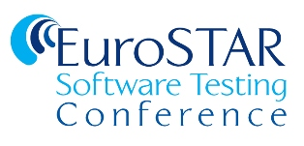

Content Submission
You
Company: State your company (or ‘Independent Consultant’ if applicable)
Biography: Please include 100-150 word biography
Photo: Please attach a high resolution headshot of yourself
Twitter: Your twitter handle if you have one

Your Material
Title: We prefer that you use a title that indicates the nature of your talk (e.g. Experiences of Test Automation) as this will help attract the right audience
Abstract: Summarise your presentation/ebook in less than 200 words
E-mail Abstract: Summarise your presentation/ebook in less than 60 words
Key Takeaways: Please identify 1-3 key takeaways from your presentation/ebook
Level: Please specify the intended (or most relevant) target audience level – Beginner | Intermediate | Advanced | All
Subject Matter: Please specify the area of testing covered in your material. If not focused on one specific area of testing, please identify the relevant primary topic e.g. project management, soft skills etc.
Promotional Video: Please record a short video (1 min max) where you will discuss the content that will be covered in your presentation/ebook/webinar. This video can be recorded on your smartphone

For Webinars Only
Poll question: Poll questions are a useful way of retaining attendee interest during webinars. Please identify 1-2 poll questions relevant to your presentation which might encourage audience participation.

For eBooks Only
Send me a word or PDF document of the content for your eBook.

